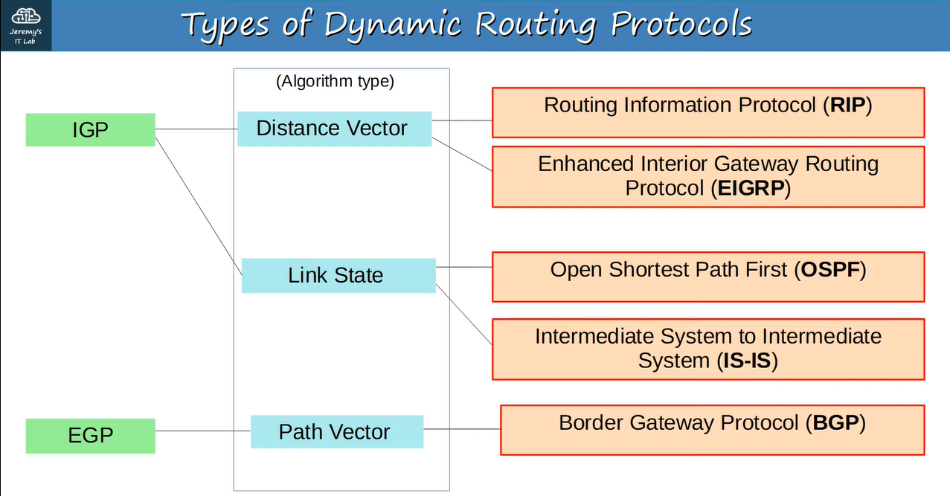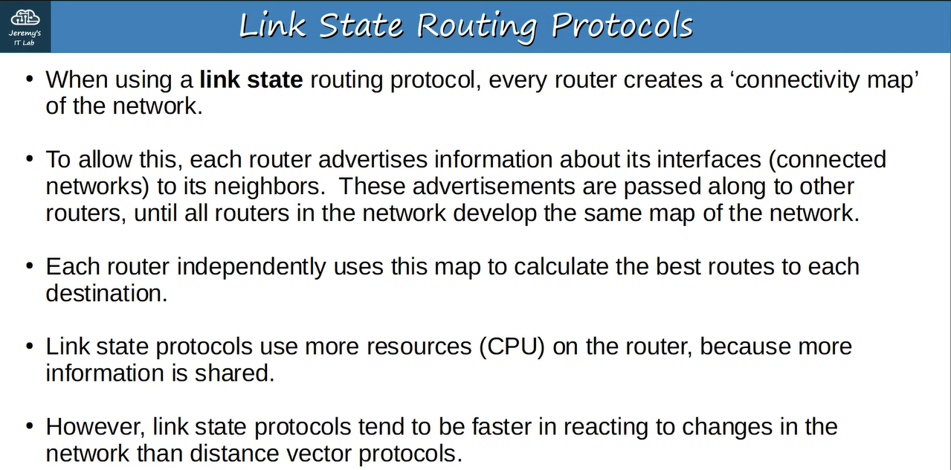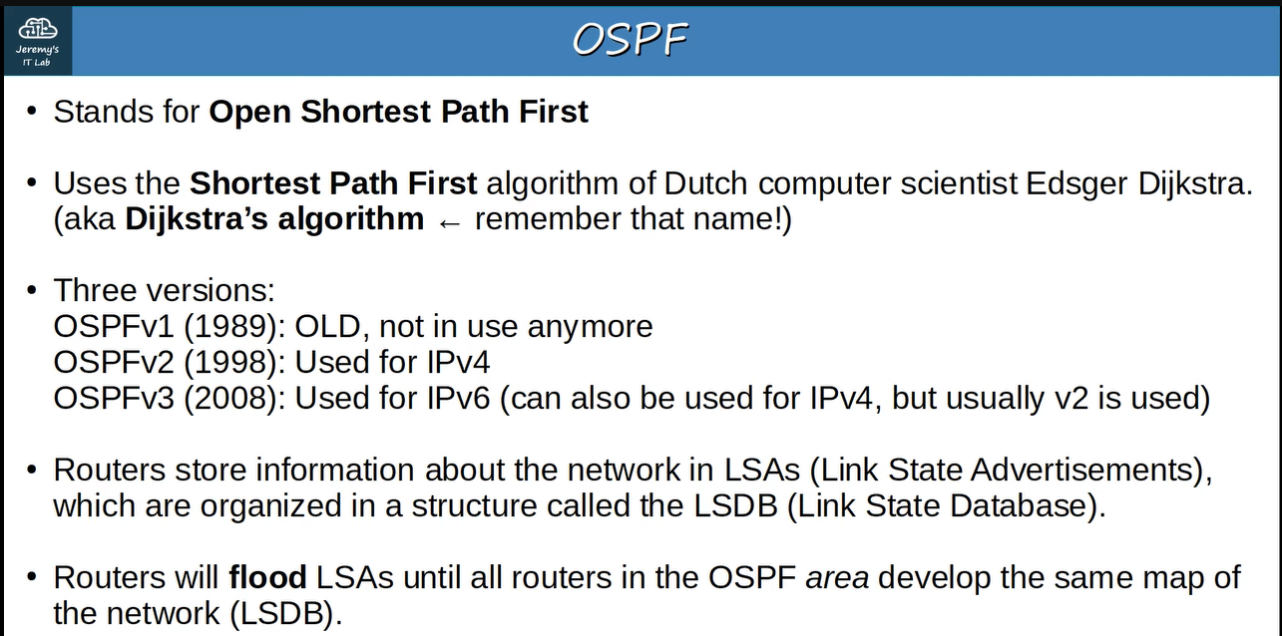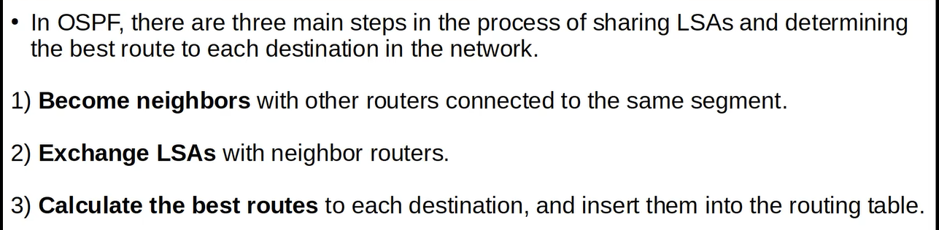**for example ↓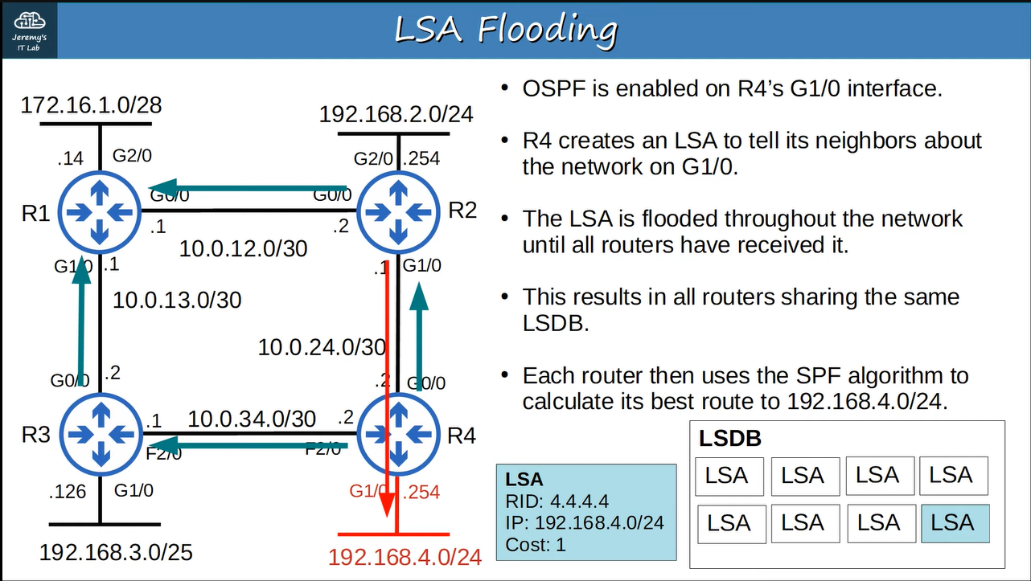if R2 wants to send the frames to the network 192.168.4.0 then it will send through G0/0 of R4**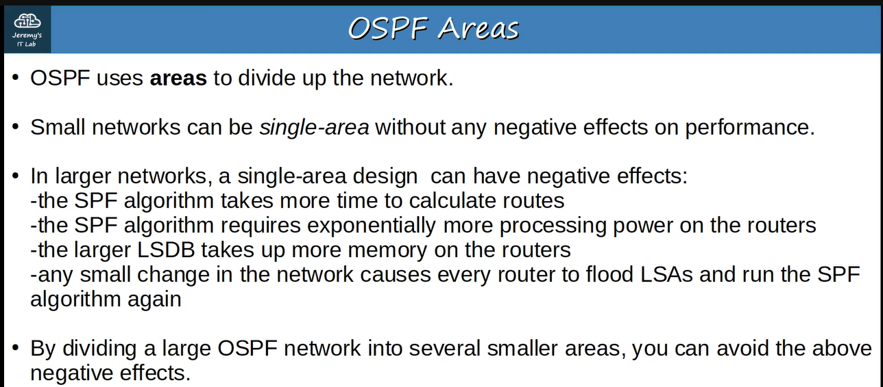

**Example of single area ↓**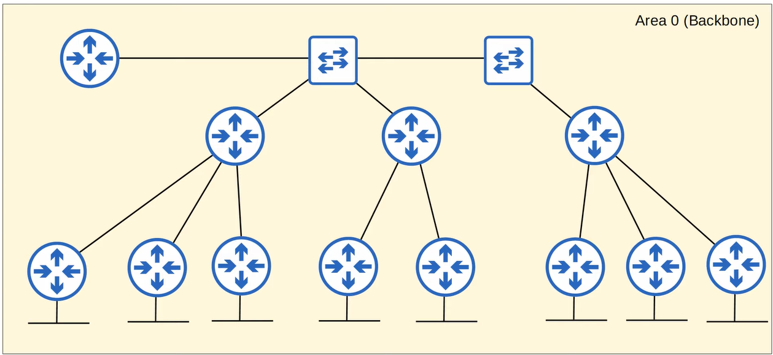

**For example ↓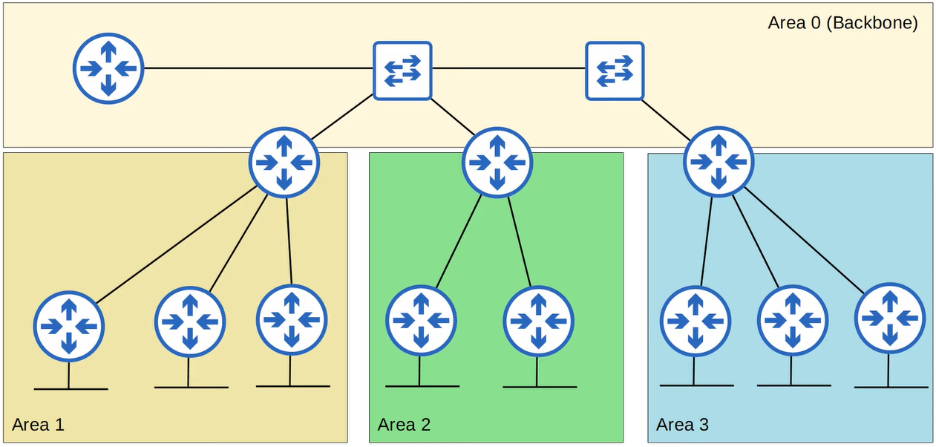this type of are is not allowed in OSPF ↓**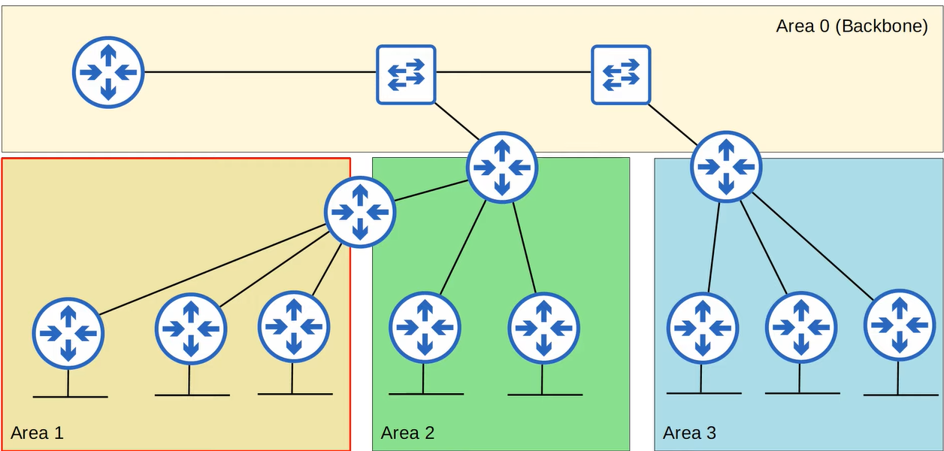

**For example ↓**

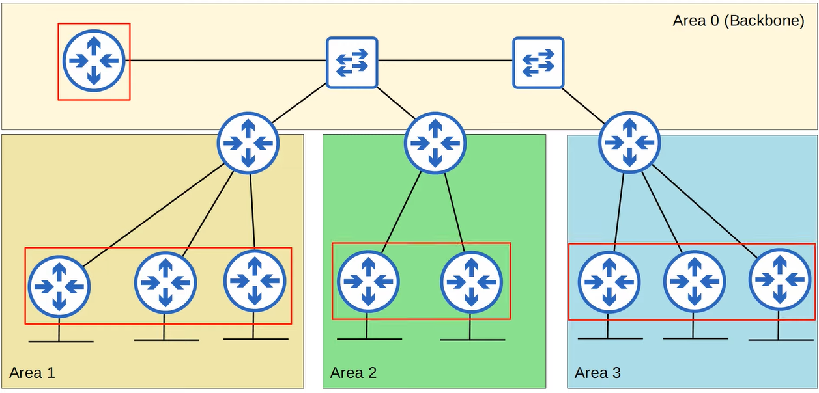

**For example ↓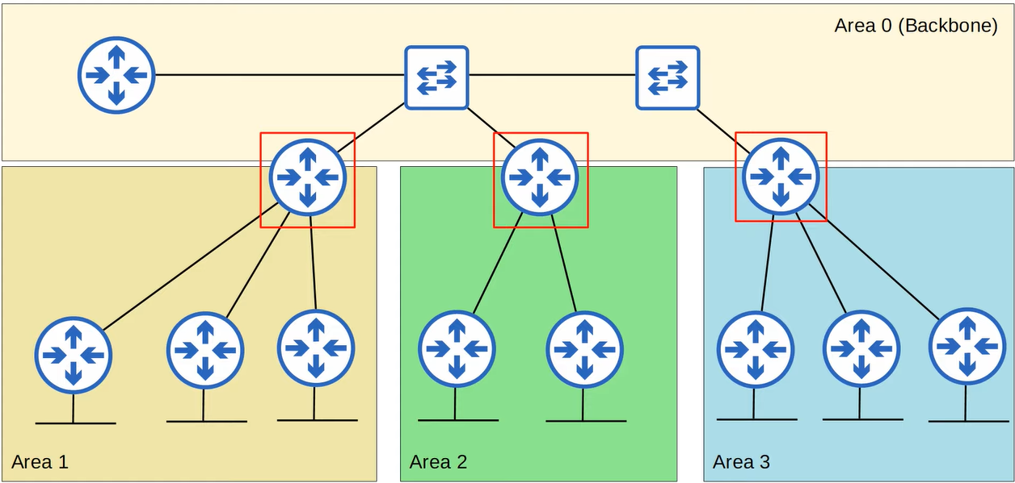Remember ↓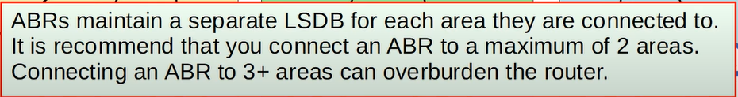For example ↓**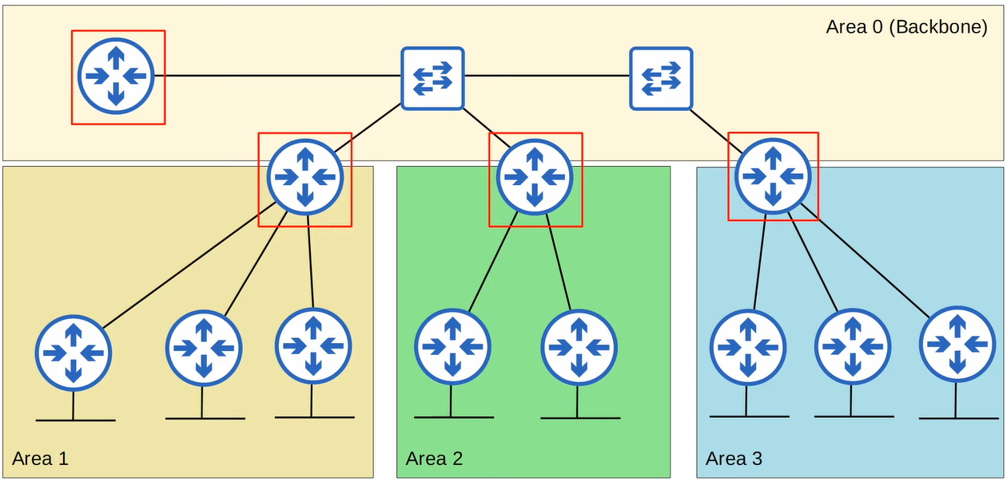

**For example ↓**

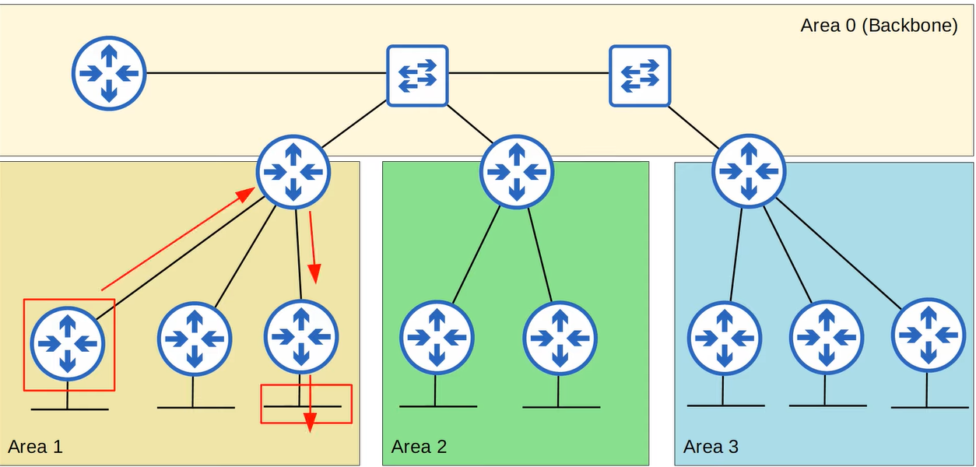**For example ↓**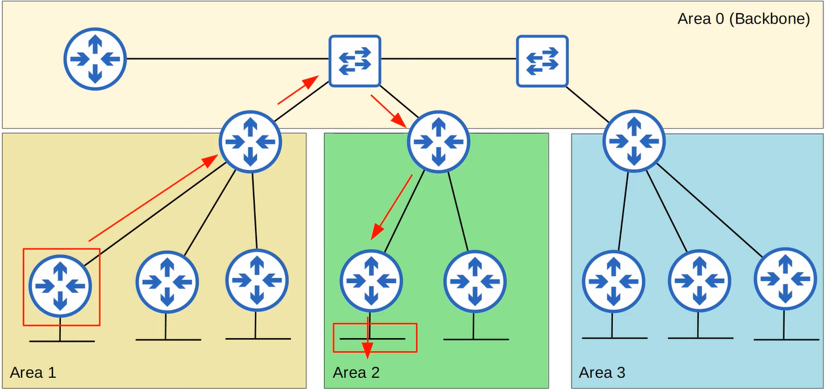

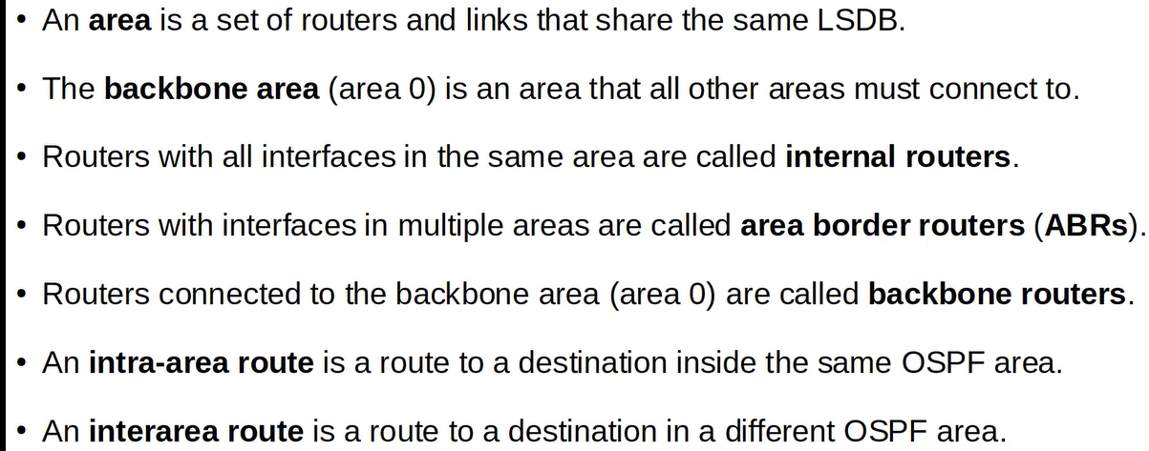

**Additional rules about OSPF areas :for example this type of network is not allowed in OSPF, because “AREA 1” has been divided into two parts ↓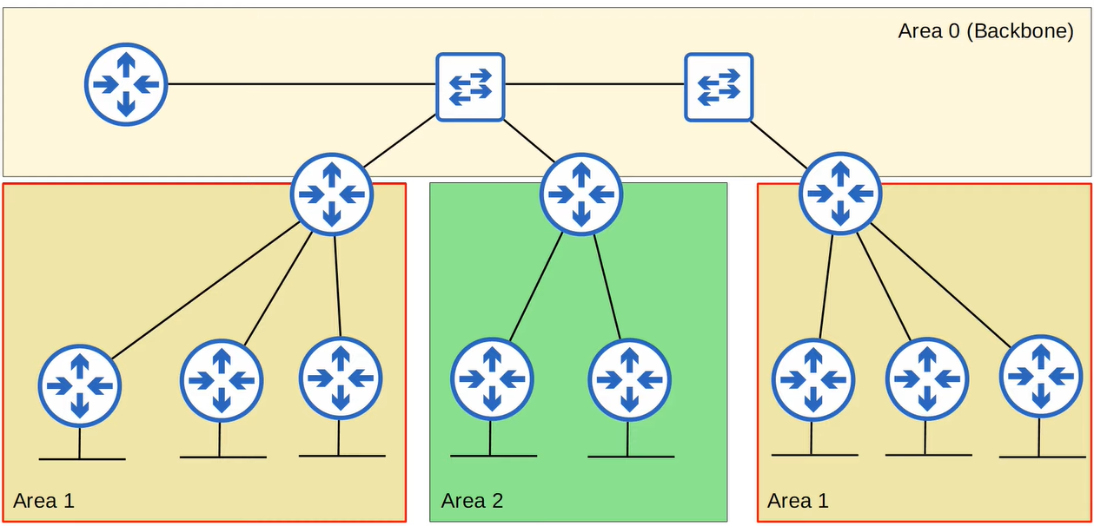for example ↓**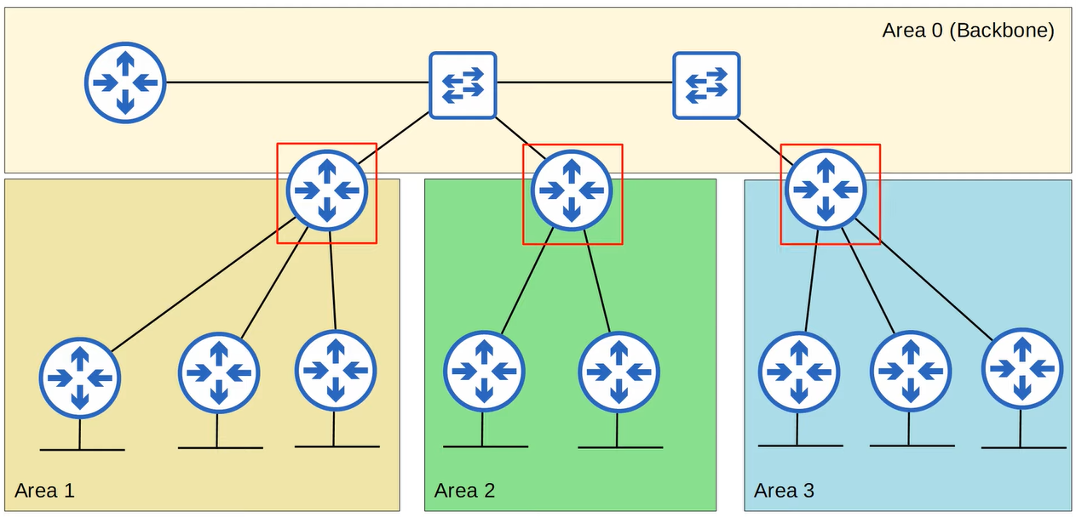

**for example ↓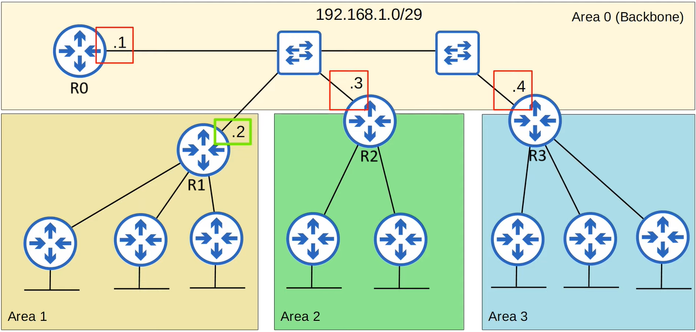in this, R1’s interface is also in the network 192.168.1.0/29 but it is not in the area “AREA 0” therefore R1 will not become OSPF neighbours with the others and 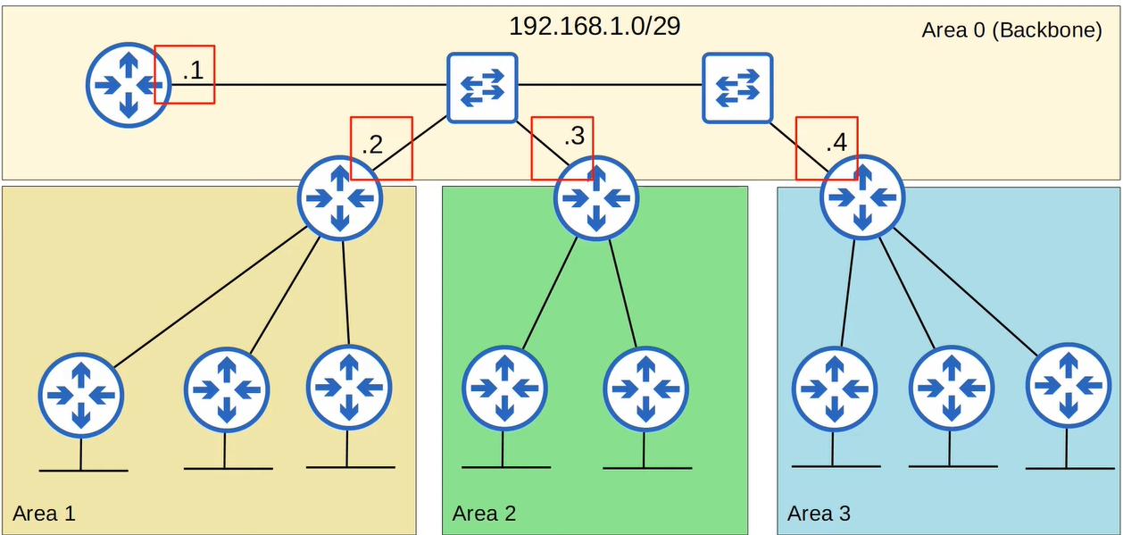 in this, R1’s interface is also in the network 192.168.1.0/29 and it is in the area “AREA 0” therefore R1 will become OSPF neighbours with the others.**

**Summary ↓**

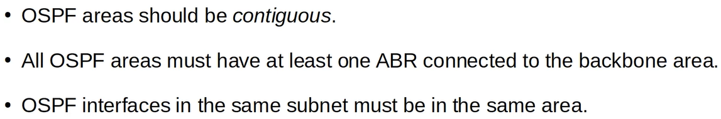

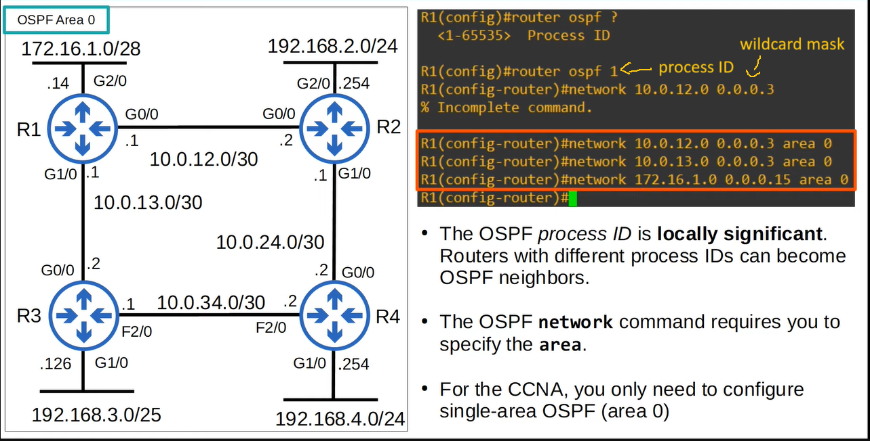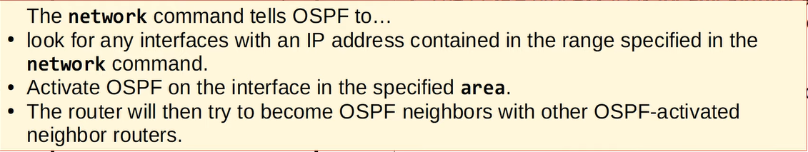**other configurations that you can do ↓**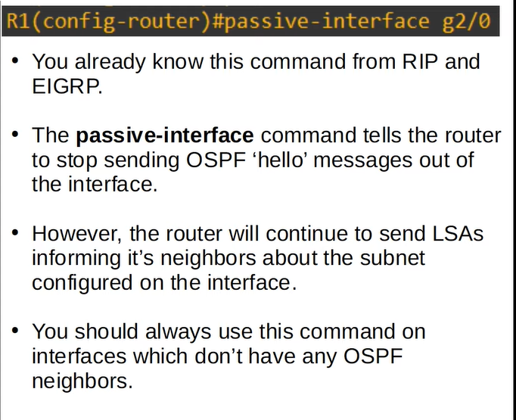

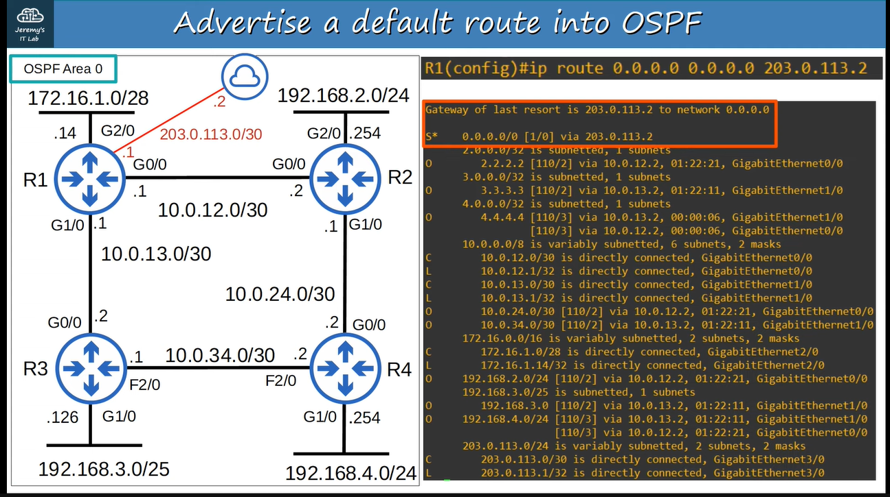**to advertise the default route into OSPF ↓**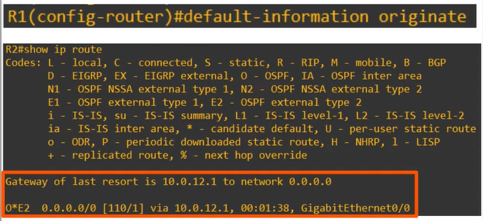

**In OSPF, this will cause the router to create a new LSA and flood it.**

